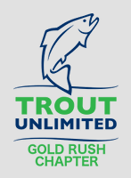
Golf Rush TU Chapter Meeting Minutes
  - April 6, 2021
Attendees: Winn Crannell, Jonathon Cabrera, Vincent Bartolomei, Atticus Leithner, Kendall Welsh, Ben Trail, George Parson, John Mauldin, Ken McKinnon, Ken Nichols, Ralph Ripley, Sam Johnson, Chris Sloan, Bill Nelson, and Mike English.
Call to Order and General Announcements
Bill Nelson, Gold Rush chapter President welcomed Gold Rush members and guests to the first “face to face” meeting since last year. A special welcome was given to attendees from the 5 Rivers North Georgia College chapter - Vincent Bartolomei, Atticus Leithner, Kendall Welsh.
Bill asked those in attendance for ideas of where to meet in June as Camp Gilsson will be unavailable during June and July to Gold Rush meetings.
Our next meeting is scheduled for May 4th and will be held at Camp Gilsson where members will discuss their experiences fishing the Davidson River in North Carolina as well the South Holston. The August meeting will also be held at Camp Gilsson with the agenda to be determined.
Bill also announced that Mike English was elected Secretary of the Georgia Council of TU. Mike’s term is two years.
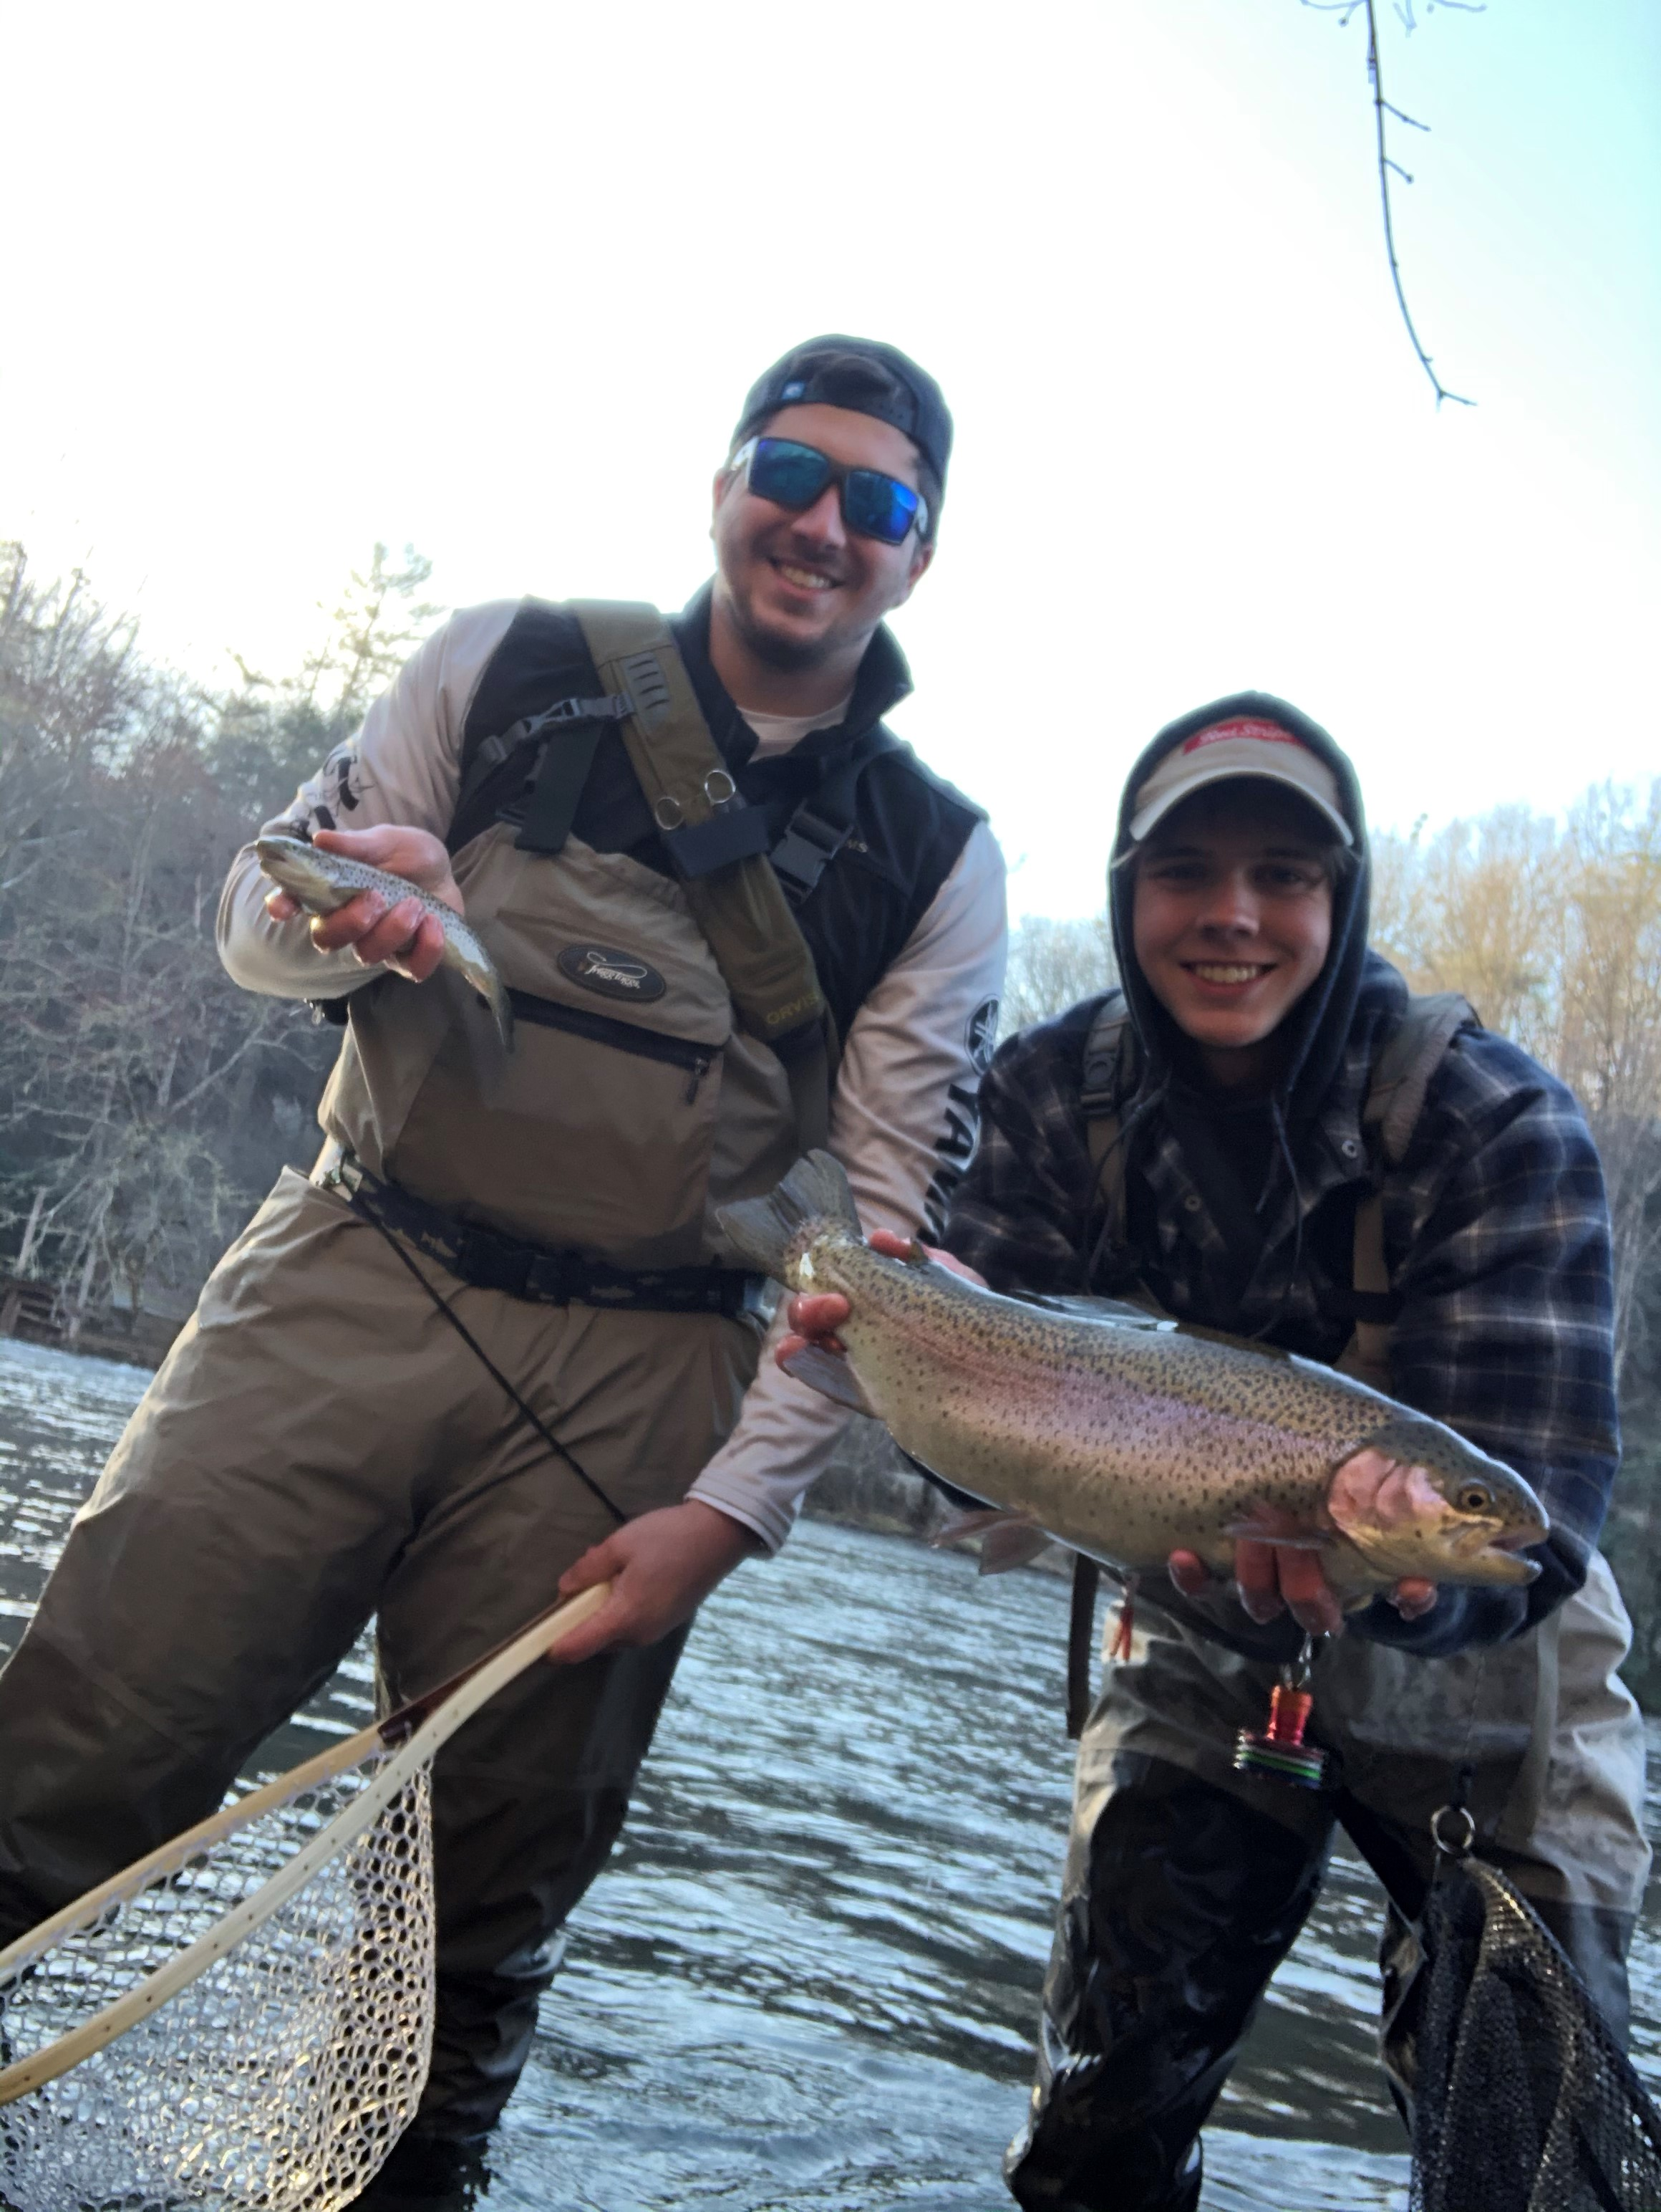
A recent 5 Rivers NGC outing netted
some impressive trout!
Atticus Leithner, President of 5 Rivers North Georgia College told those in attendance that their chapter has 10 members with several freshman arriving that are experienced fly fishermen.
There was no treasurer report this month.
Gold Rush Fishing Report
Mike Thornton, Sam Johnson, Chris Sloan, Fred Ruppel and Mike English ventured to the Davidson for some very cold fishing April 1 to the 3. They will report during next month’s chapter meeting. John Mauldin and Bill Nelson are fishing at the South Holston Lodge in the next few weeks. You might remember the Jon Hopper, manager of the South Holston Lodge presented to the chapter during our December 2020 Zoom meeting. Chris Sloan and Sam Johnson are also heading up to the South Holston soon. Frog Hollow will host members of Gold Rush this coming Saturday the 11th. John Mauldin and Bill Nelson are coordinating the Frog Hollow outing. Ken Nichols just got back from Mexico where he and others saltwater fly fished.
Project Healing Waters
Ken McKinnon announced that Project Healing Waters is back up and running after the COVID shutdown. Bob Post and Deb Scott are holding online fly-tying programs every Thursday. Bill asked if Chris Sloan could work with Ken to augment the fly-tying program, which Chris agreed to do.

Trout Camp 2021
This year’s trout camp will be a day camp and is scheduled on June 5 and 6. Gold Rush is sponsoring Eli Pearson. The camp will be held at Atlanta Fly Fishing’s Cumming location. On Sunday the 6th, Eli and the other students will fish with Unicoi Outfitters on the upper Chattahoochee.
Workdays
Bill talked about the upcoming workday for Lovinggood Creek, July 10th. The lead chapter is Oconee River with the Gold Rush, Foothills and UGA 5 Rivers chapters all supporting the effort. Other upcoming workdays include:
- Wilkes Branch of the Upper Chattahoochee, July 17th
- Pretty Branch, August 14th
- Johns Creek, August 21st
- Outdoor Adventures Day, Georgia DNR, September 25th

Fly Fishing the North Fork of the French Broad River
Chris Sloan opened the presentation discussing the work that Sam and he are doing as part of Wild Bearings (https://wildbearings.com/). Sam noted that approximately 120 to 125 people have attended each of the Fly Fishing the Blue Ridge Parkway webinars. Previously recorded webinars can be found on YouTube or accessed on Wild Bearing’s site.
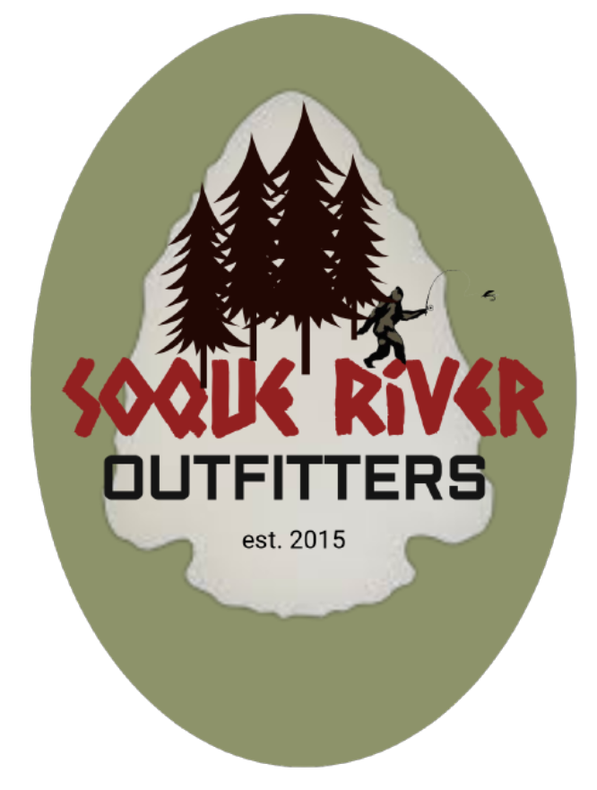
www.soqueriveroutfitters.com
Chris noted that Big T, a sponsor, contributor, and friend to the Gold Rush chapter has opened Soque River Outfitters, located at 159 Walls Complex Circle, Clarkesville, GA 30523. He urged those in attendance to support Big T and then handed the presentation to Sam.
Sam began his segment of the presentation providing a general overview of the Blue Ridge Parkway and noted that 10% of his book sales profits go to the Blue Ridge Parkway Foundation. For those of you interested in acquiring a copy of Sam’s book, Amazon, as well as many fly shops carry the book. You can purchase the book online at Amazon by clicking on this link, Fly Fishing the Blue Ridge Parkway: North Carolina Section: Sam R. Johnson: 9781631837234: Amazon.com: Books.
Sam’s book breaks fishing the Blue Ridge into five major sections. Our April 6th Gold Rush presentation focused on the North Fork of the French Broad River, which is located in Section 1, MP 469 to MP 406. Sam rates the area a five with good to excellent fishing in all segments for Brook, Browns and Rainbow. The headwaters of the French Broad River are fed by Courtyard Creek and Kiesee Creek. Tributaries include Tucker Creek, Longbranch Creek and Beetree Fork. The river from source to its mouth at Hwy 64 is 12.7 miles.
Sam’s address of the North Fork of the French Broad River segmented the river into six sections:
- Section 1 of the French Broad River parallels Hwy 215 from the mouth located at Hwy 64 until the Lazy Jay Campground, 1.9 miles upstream. Access is fairly easy with parking found along Hwy 215. This section is largely flat.
- Section 2 also parallels 215, running from the campground to the confluence of Big Bearwallow Creek. Pull offs for parking are plentiful but getting to the stream is an effort considering the elevation difference between the road and stream. The stream is 5 to 7 yards wide and 20 to 24 inches deep. Casting is open.
- Section 3 is a difficult area to fish and best not fished alone. It begins at the entry of Big Bearwallow Creek, running 2.1 miles to a lake at Big Mountain Branch. You will need to hike a tough climb back up to Hwy 215 to exit. Plan two days to fish this section.
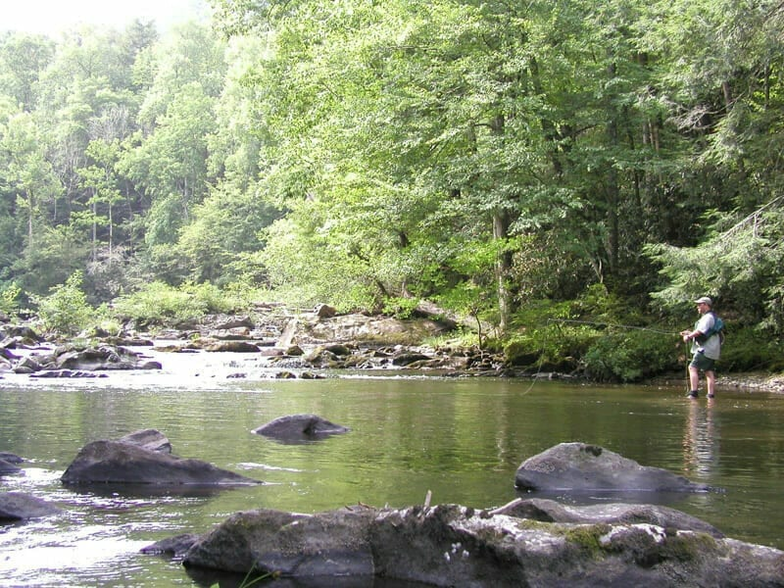
North Fork of the French Broad River
- Section 4 is also best not fished alone. This section can be accessed by hiking down a trail from the highway to near the lake. The section begins at the lake and is 1.8 miles long, ending upstream at the bridge crossing Hwy 1379/Macedonia Church Road. Sam noted a government installation he has dubbed “Area 51” is in this section that he entered and was quickly escorted out.
- Section 5 of the French Broad River parallels Hwy 215 for 4.6 miles from Macedonia Church Road to a bridge at Hwy 215 and Forest Service Road 140. Sam noted that there is not a lot of public fishing in this area, but this area includes the confluence of Tucker Creek, which is good fishing once you get into the National Forest. Sam noted that above the Macedonia Church Road bridge there are pools holding fish in deep water midstream as well as along the stream banks. Sam also noted that you should visit the Living Waters Retreat while in the area to view the twin waterfalls and to fish. Lastly, he made mention of the Cathedrals Falls as a notable place to also visit.
- Section 6 of the French Broad River is 5.6 miles, ending at the source where it is fed by Courtyard Creek and Kiesee Creek. Courtyard Creek has splendid waterfalls and a 11% gradient. This section also includes Beetree Creek.
Sam highly recommended those interested fishing the North Fork of the French Broad River acquire National Geographic maps of the area that show what fishing access is public and private.
Unfortunately, the meeting was adjourned by building alarms before Sam finished.

Quote of the Month
"If fishing is like religion, then fly-fishing is high church."
~ Tom Brokaw

May TU Gold Rush Meeting
Our next meeting is scheduled for May 4th and will be held at Camp Gilsson where members will discuss their experiences fishing the Davidson River in North Carolina as well the South Holston.
