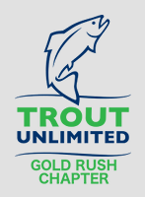
Golf Rush TU Chapter Meeting Minutes
  - March 2, 2021
Attendees: Deb Scott, John Mauldin, Mike Thornton, Ken McKinnon, Jim Brewer, Ken Nichols, Sam Johnson, Jamie Brewer, Ralph Ripley, JC, Chris Sloan, Steve Roll, Bill Nelson, and Mike English. Special guest was Sean Branon.
Fly Fishing in the Western Waters
Our host for the evening was Sam Johnson, long-time TU member, notable fly fisherman and author. Sam brought together several chapter members; Mike Thornton, Ken Nichols and a friend of Chris Sloan that lives in Colorado named Sean Branon to talk about their experiences fishing in the Western U.S.
Sean Branon and the Colorado River Headwaters
Sean lives in Granby, Grand County, CO and has fly fished since he was 12 years old. He and Chris Sloan used to work together.
The headwaters of the Colorado River start in the Rock Mountain National Park and flow through Grand County, which is less than a 2-hour drive from Denver. Sean noted that the rivers and creeks within Grand County are much less pressured than other more well-known rivers in Colorado. The upper Colorado river is an open stream surrounded by Sage brush and sees many windy days. Double hauling is a must.
In 1952 to 1955, Grand County was considered President Eisenhower’s Western White House, who was an avid fly fisherman. Fraser River, a feeder to the Colorado, is still thought of as the “Presidential River” by the locals.
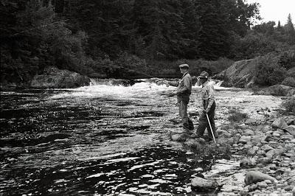
Sean talked about the several sections of Colorado and its tributaries that include Fraser River, Williams Fork River and Willow Creek. The river system consists of public waters and sections that flow through private land. Sean talked about the Rocky Mountain Angling Club, www.rmangling.com where members have exclusive access to catch and release fly fishing by way of arrangements with @ 165 private property owners throughout the Rocky Mountains.
Colorado River and its Tributary Hatches
While Grand County does get cold, it also has abundant hatches throughout the year. Midges hatch all year, May Flies from February to December, Caddis from April to November, Stone Flies in January and February as well as April to October, and Terrestrials during April to October. Sean’s favorite midge is a Barr’s emerger and his “go to” dry is a Parachute Adams. His favorite terrestrial is Chubby Chernobyl. Streamers are must to catch trophy trout. Salmon flies also hatch during a two-week period in May.

Fraser River
The Fraser is 32 miles in length with the first few miles open to the public. The Fraser has Brook and Brown but no Cutthroat Trout, which are found farther up the headwaters. To Granby, the Fraser is wadable with sections averaging 15 inches in depth. Sean noted that is it best to employ a local guide to get access to the best fishing.
Colorado River
Sean reviewed the fishing in the upper section of the Colorado near Grand Lake where there is predominantly Brook Trout. Below Shadow Mountain is where the tailwater begins. Notable is Windy Gap, where during early June to July there is a freshwater shrimp hatch. Best fly is the Mysis Shrimp Fly. From Hot Sulphur to Kremmling is a “gold metal” section of the Colorado. It parallels Hwy 40, providing many quality angling opportunities for Rainbow and Brown trout averaging 14 to 20”. Williams Fork on the Colorado is a 200 cfs stream during the summer and is a mile and a half hike for great fishing. If you can only fish one river, Williams Fork is his recommendation. Best to float the 70 mile section from Kremmling to Dotsero with larger size flies in your box.
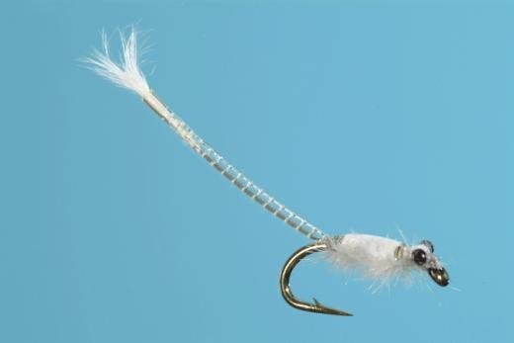
Mike Thornton and the Big Horn River
For many years, Mike and friends have taken a pilgrimage to the Big Horn in southeast Montana during late spring. Located in Fort Smith, it is a 2- hour drive from Billings, the nearest airport. Or you can take a serious non-stop road trip of 1 ½ days from the Atlanta area. Fort Smith is a sleepy town of a few hundred people with three fly shops. Our kind of town!
The Big Horn is a 400-mile river that merges with Yellowstone. There is a 13-mile section near Fort Smith Mike fishes. He uses a 12’ leader and size 12 midges when fishing in the Spring. Mike, dressed in parkas, featured pictures of a number of large Brown and Rainbow trout. Always with a big grin on his face.
Ken Nichols and the Big Hole River
Also found in Montana is the Big Hole River which is one of Ken Nichols favorites. He goes to the Big Hole most every August with friends that are local to the area. The Big Hole is the only river in Montana with native Grayling. Ken told the group that he has caught White, Brown, Brook, Rainbow, Grayling, and Greenback Cutthroat all in one day. Talk about a “grand slam”! Ken and his friends float a 15-mile stretch of the Big Hole. Per Ken the river boasts 3,000 fish per mile in the stretch they fish, which makes for some great days fishing. Ken noted that there is a Tricos (Tricorythodes mayflies ) hatch during August and his favorite fly is a Parachute Tricos, size 20 to 24. There is also a Salmon fly hatch in June.
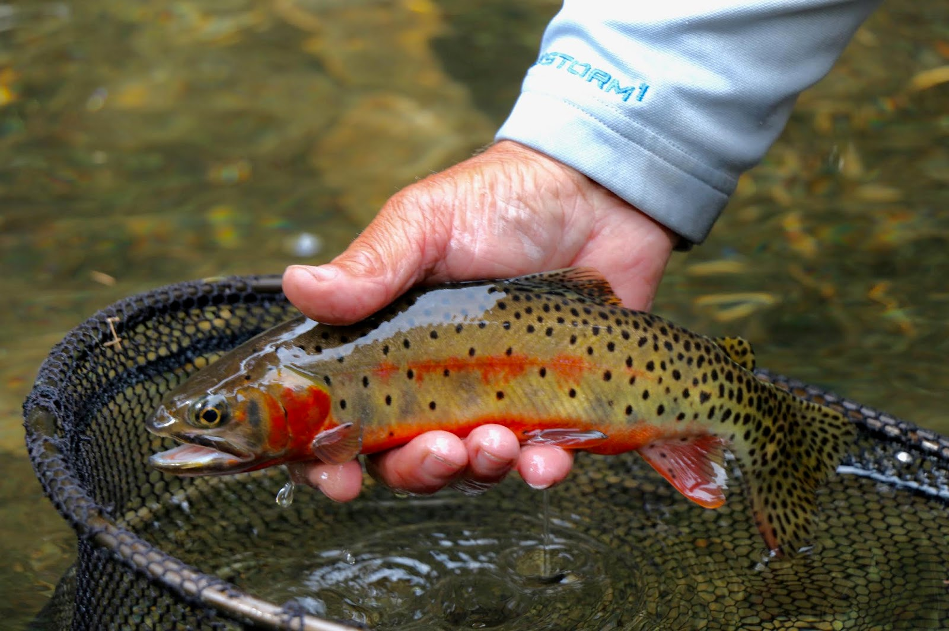
Ken also showed some pictures of an incredible drift boat he built from scratch for a friend that he fishes with in Big Hole with help from John Maudlin and Vince Giordano. The effort took over 450 hours and is a work of art.
Sam Johnson and the Big Thompson in Colorado
In 1915 the Rocky Mountain National Park was founded, and part of the park is Moraine Park, a 2000-acre grass land sanctuary. Moraine features one local trout, the Greenback Cutthroat Trout that is native as well as exotic species that include Brook, Brown and Rainbow. The town of Estes Park is on the edge of Moraine Park has some incredible fishing in the town. Elevations in the area can range from 8,000 to 14,000 feet.
Sam talked about three areas of the Big Thompson – Forrest Valley, The Pool and Moraine Park. The Big Thompson River is fed by the Spruce, Fern and Cub Creeks. The Pool predominantly hosts Brook Trout, some 10 inches. Forest Valley requires a hike to the center, a 2,000-foot descent over ¾ of a mile. Not bad going down but after a long day fishing… Forest Valley, a rugged area, is a source for Big Thompson and Sam suggests getting National Geographic maps and not going alone!
Miss the Zoom meeting and want to see the presentations?
If you’d like to see a recording of the meeting and the great presentations, click on this link, https://us02web.zoom.us/rec/share/nQcZzGfzxBeF68A3ZztxgukaQSUFOh8h0-jc9nZE9fcKqvGzzXWgJxOLyDYXKdr2.B7eR6s13a23EOTEs.

